**API specification——音乐播放**

members：窦锦涛 ID:16301085

厉欣林 ID:16301096

our group design a musicplayer service and a interface to finish the music play.

**the package dependency**

service:

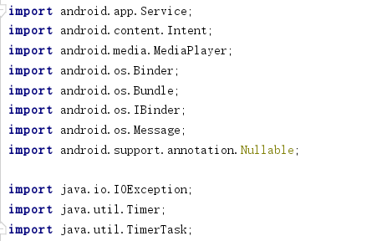

the implement:

Contact to the interface:

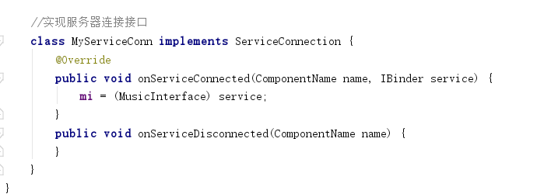

stop play the music:

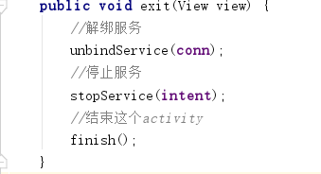

Resume after pause:

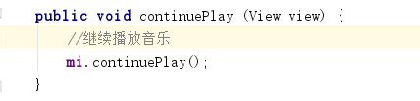

Pause the play:

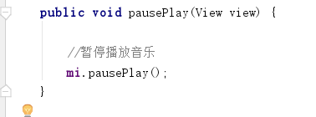

Play it:

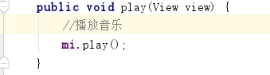

Create a Message handler object:

